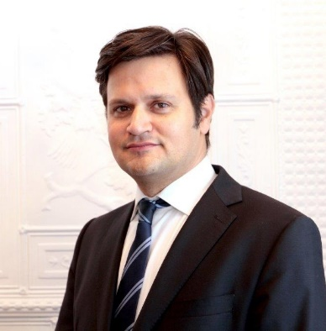

Bálint ÓDOR

Nationality Hungarian
Date of birth 23 May, 1975
E-mail cor2.beu@mfa.gov.hu
Personal details married, two daughters

Work experience

01.09.2022. - Ambassador, Permanent Representative
Permanent Representation of Hungary to the EU

01.07. 2022. Chargé d’affaires ad interim
Permanent Representation of Hungary to the EU

2020 – 2022 Ambassador, Representative to the EU Political and Security Committee
Permanent Representation of Hungary to the EU

2014-2020 Ambassador
Embassy of Hungary to Canada

2010-2014 Deputy State Secretary for European Affairs, European Director
Ministry of Foreign Affairs, Hungary

2004-2010 Head of Section and Head of the EU Department
Hungarian National Assembly, Office for Foreign Relations

2002-2004 Counsellor in the Department for EU Integration and Institutional Affairs
State Secretary for Integration and External Economic Relations
Ministry of Foreign Affairs

2000-2002 Analyst at the Department of Strategic Planning
Ministry of Foreign Affairs

Education and training

2014
Title of qualification awarded PhD in international relations
Principal subjects/occupational skills covered Topic of Dissertation: Decision-making under the double majority system introduced by the Lisbon Treaty

Name and type of organisation providing education Corvinus University, Budapest

1994 – 1999
Title of qualification awarded Dipl. Rerum Politicarum (Economist)

Name and type of organisation providing education University of Fribourg, Switzerland

Personal skills and competences

Languages:
Hungarian first language
English fluent
French fluent
Italian intermediate
German intermediate

