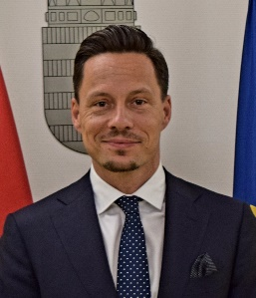

Levente BÁNFALVI

Nationality Hungarian
Date of birth 19 February 1980
Contact psc.beu@mfa.gov.hu

Professional experience
01.09.2022- Ambassador, Representative to the EU Political and Security Committee
Permanent Representation of Hungary to the EU

2015-2022 Deputy Ambassador (EU Political and Security Committee)
Permanent Representation of Hungary to the EU

2010-2015 COEST-delegate
Permanent Representation of Hungary to the EU

2010 Head of Unit – Strategic Planning Department
Ministry of Foreign Affairs, Hungary

2007-2010 Foreign- and security policy analyst – Open Source Intelligence Unit
Ministry of Foreign Affairs, Hungary

Education
2003-2005 Corvinus University, Budapest (International Relations – Master)
1999-2003 University of Nyíregyháza, Hungary (International Relations – Bachelor)
2004-2005 Scholarship (Radboud University, Nijmegen, The Netherlands)

Language Skills
English
German
French

Experience/Membership
        - Lecturer - Zrínyi Miklós University of National Defence
        - Founder - ’Budapest Club’ - Open Source Initiative (2007)
        - Board Member - European Union Institute for Security Studies (EUISS)
        - Board of Governors Member - European Endowment for Democracy (2013-2015)
        - US International Visitor Leadership Program (2011)
        - President - International Diplomat Cycling Club (IDCC)
        - European Computer Driving License (ECDL)
        - Johan Cruyff Institute Alumni

